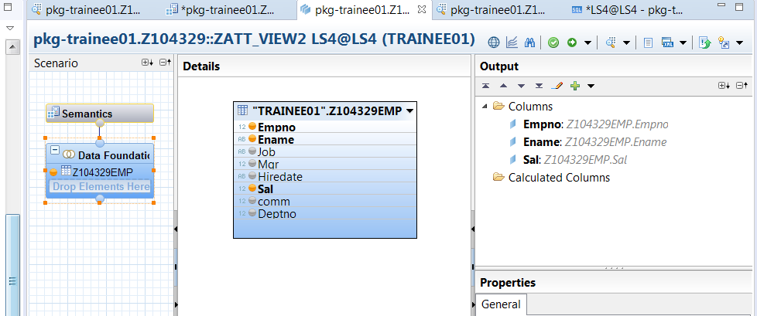

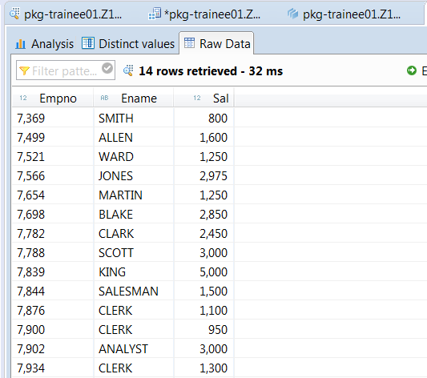

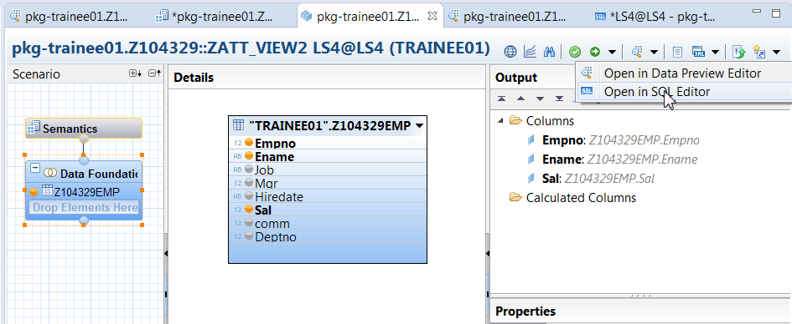

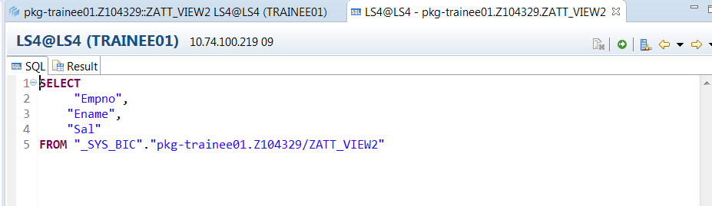

Consuming the above attribute view in ADBC

REPORT Z.  
DATA orf_1 TYPE REF TO cx_root.  
TYPES: BEGIN OF TY_EMP,  
         EMPNO   TYPE Z104329EMP-EMPNO,  
         ENAME    TYPE Z104329EMP-ENAME,  
         SAL   TYPE Z104329EMP-SAL,  
       END OF TY_EMP.  
DATA : WA_EMP TYPE TY_EMP,  
       IT_EMP TYPE TABLE OF TY_EMP.  
  
DATA: O_CONN   TYPE REF TO CL_SQL_CONNECTION,  
      O_SQL    TYPE REF TO CL_SQL_STATEMENT,  
      O_RESULT TYPE REF TO CL_SQL_RESULT_SET,  
      V_SQL    TYPE STRING,  
      O_DATA   TYPE REF TO DATA,  
      V_COUNT  TYPE I.  
  
TRY.  
  
CREATE OBJECT O_SQL.  
V_SQL = |SELECT   "Empno", "Ename", "Sal" FROM "_SYS_BIC"."pkg-trainee01.Z104329/ZATT_VIEW2"|.  
  
CALL METHOD O_SQL->EXECUTE_QUERY  
  EXPORTING  
    STATEMENT  = V_SQL  
  
  RECEIVING  
    RESULT_SET = O_RESULT.  
  
GET REFERENCE OF IT_EMP INTO O_DATA.  
CALL METHOD O_RESULT->SET_PARAM_TABLE  
  EXPORTING  
    ITAB_REF = O_DATA.  
  
CALL METHOD O_RESULT->NEXT_PACKAGE  
  RECEIVING  
    ROWS_RET = V_COUNT.     
WRITE V_COUNT.  
  
CATCH CX_SQL_EXCEPTION INTO orf_1.  
  WRITE 'EXCEPTION OCCURED'.  
  WRITE: / 'Text is:', ORF_1->GET_TEXT( ).  
  WRITE: / 'Long Text is:', ORF_1->GET_LONGTEXT( ).  
  
ENDTRY.  
  
  
CL_DEMO_OUTPUT=>DISPLAY( IT_EMP ).